Run this page off on colored paper.

Cold Front Warm Front

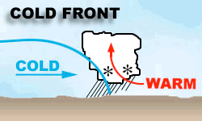
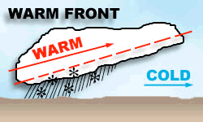

Warm Front Cold Front

Warm air mass meets Cold air mass overtakes &
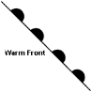

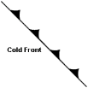

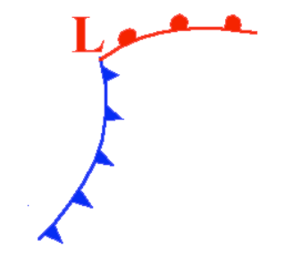

& rises above cold air mass pushes under warm air mass

Slow, steady rain Heavy rains, and
Violent thunderstorms

Hot, humid weather follows Fair, cool weather follows

More gentle slope Steeper slope

Warm Front Cold Front

Warm air mass meets Cold air mass overtakes &

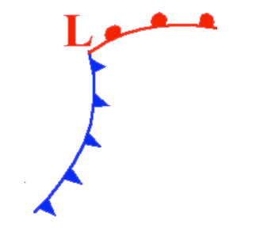

& rises above cold air mass pushes under warm air mass

Slow, steady rain Heavy rains, and
Violent thunderstorms

Hot, humid weather follows Fair, cool weather follows

More gentle slope Steeper slope

Make a Fronts Foldable!
Name__________________________________ Class______

DIRECTIONS:
1. Fold the Venn Diagram page in half.
2. Cut out the three symbols and glue in the correct part of the Venn Diagram.
3. Cut out the diagrams and glue inside in the correct places.
4. Cut out the descriptions and glue inside in the correct places.
5. Use the diagrams and descriptions from the inside to fill in the Venn Diagram on the front.
Try for at least three things for the Cold and Warm Fronts that make them different
from each other. Then try for at least three things they have in common and add to the
center of the Venn Diagram.
6. Answer the Questions below using your Venn Diagram Fronts Foldable.

Fronts Foldable Questions:

1. Why does warm air rise at a front?!

2. Why does cold air stay close to the ground?

3. What are the first signs of an approaching warm front?

4. What are the first signs of an approaching cold front?

5. What type of weather is associated with a cold front?
warm front?

6. List two ways cold and warms fronts are similar or related to each other: (a)
(b)

7. Which front moves through an area faster? Why?
slower? ______________ Why?

8. If a warm front occurs in the winter, what type of snow storm would it likely bring?

9. If a cold front occurs in the winter, what type of snow storm would it likely bring?

10. Which type of front would likely bring hail and possible tornadoes into an area?
How do you know?

Interactive Student Notebook
Fronts Foldable:

(1) Make a pocket for the Fronts Foldable. Paste on Left Side. Put your foldable in the Pocket. (2) Use your Foldable to answer the questions below and then paste on the Right Side. or use
Weather Along a Front Worksheet.

Fronts Foldable Questions:

1. Why does warm air rise at a front?!

2. Why does cold air stay close to the ground?

3. What are the first signs of an approaching warm front?

4. What are the first signs of an approaching cold front?

5. What type of weather is associated with a cold front?
warm front?

6. List two ways cold and warms fronts are similar or related to each other:
(a) (b)

7. Which front moves through an area faster? Why?
slower? ______________ Why?

8. If a warm front occurs in the winter, what type of snow storm would it likely bring?

9. If a cold front occurs in the winter, what type of snow storm would it likely bring?

10. Which type of front would likely bring hail and possible tornadoes into an area?
How do you know?

Weather Along a Front (Color the Fronts and Pressure Centers.) Name Class
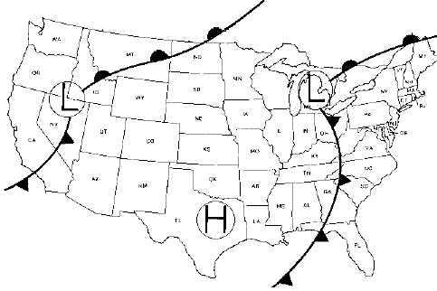

1. Warm Fronts: As a warm front approaches, the sequence of clouds is:
cirrus, cirrostratus, altostratus, nimbostratus, and stratus.

a. What kind of weather do you think happens when a warm front moves through an area?

b. How do you know? What did you use to figure this out?

2. Cold Fronts: As a cold front approaches, the sequence of clouds is:
cumulus, cumulonimbus with some cirrus trailing off the cumulonimbus clouds.

a. What kind of weather do you think happens when a cold front moves through an area?

b. How do you know? What did you use to figure this out?

3. What type of weather will our area experience tomorrow?

A. How do you know? What is your evidence?

© Copyright 2010.! M. J. Krech. All rights reserved.

Stationary and Occluded Fronts

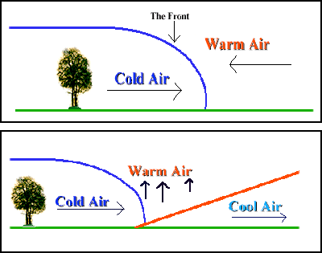

STATIONARY FRONT

OCCLUDED FRONT

1. How does a Stationary Front differ from an Occluded Front?

2. Describe the weather conditions which accompany an Occluded Front:

3. Describe the weather conditions which accompany a Stationary Front:

4. What is the relationship between a Cold Front and a Stationary Front?

