Honors Earth and Environmental Science - Erosion Webquest
Go to the following link: http://www.pbslearningmedia.org/asset/ess05_img_erosion/
View each slide and read the description. Answer the following questions. Each question corresponds to one of the 7 slides.

- What is one factor which makes rocks more or less vulnerable to erosion?
- The cause of erosion described here is rock broken apart by _________, which is a process of _____________ weathering.
- In which environment would wind erosion be most pronounced? (circle one)
  - Rain forest
  - Desert
  - Mountain range
- The erosion on the left is the result of what type of weathering?
- How does agriculture lead to increased erosion?
- In what way do the large rocks lining the riverbank protect it from erosion?
- The sand fences on a beach are a defense against what type of erosion?
Water is an erosive feature not just in streams, but along coastlines. Glaciers also erode the landscape as the move. Streams tend to form V-shaped valleys. Glaciers tend to form U-shaped valleys and oceans and lakes erode coastlines. Now access this link: http://www.pbs.org/wnet/nature/lessons/breaking-it-down/video-segments/1702/ View the first video clip.

- Were the Hawaiian cliffs formed only by erosion? If not, what other factors helped form these cliffs?
- Hawaii has a hot and humid climate? Do you think chemical weathering is common on the islands of Hawaii?
- Go back to the link above and view the second video clip. As you watch the video, write down three places that water is flowing.

Look at the graph below. What can you conclude about the capacity of higher velocity streams to carry sediment particles?
- Does Hawaii’s mountainous terrain make water erosion more or less significant and likely?
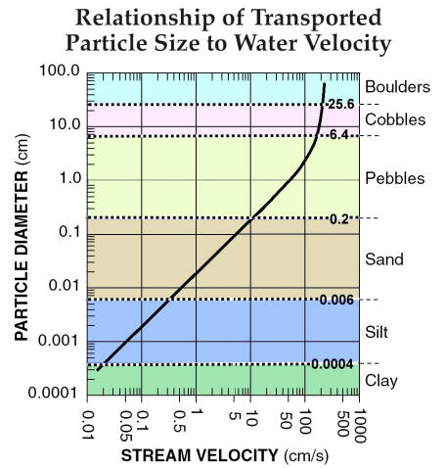
- What measures have Hawaiians taken to prevent damage to their homes from landslides?

