Unicellular Organisms

Structure of a Euglena
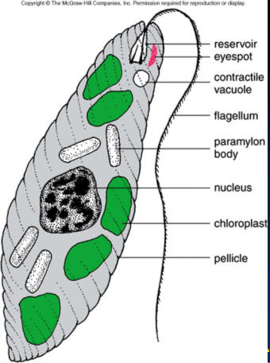

1. What two things are present in this unicellular organism that may help it respond to the light and allow it to complete photosynthesis?

2. What cell part is responsible for regulating water levels within this organism?

Unicellular Organisms

Structure of a Euglena

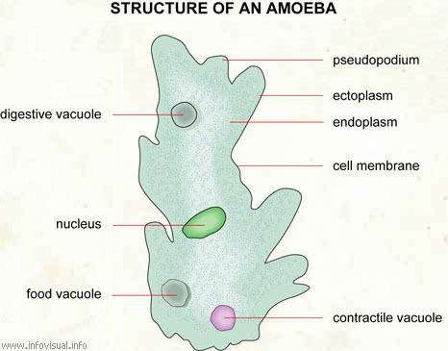

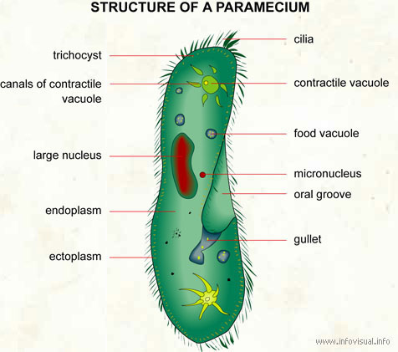

1. Each of these unicellular protists has a unique cell structure that allows it to move around in its environment. List the three unique structures.

Organelles

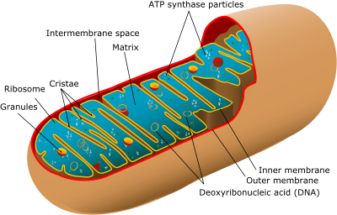

1. Which cell organelle is represented by the picture above?

2. What cell process occurs in this organelle?

3. What advantage does this organelle gain from its folded inner membrane?

Organelles

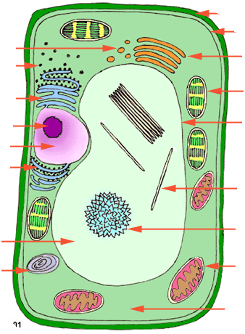

Match the following organelles with their corresponding letter on the cell diagram:
1. ribosomes
2. nucleus
3. mitochondria
4. cell membrane
5. cell wall
6. vacuole
7. chloroplast

Cell division

1. Put the diagrams of the cell cycle in order.

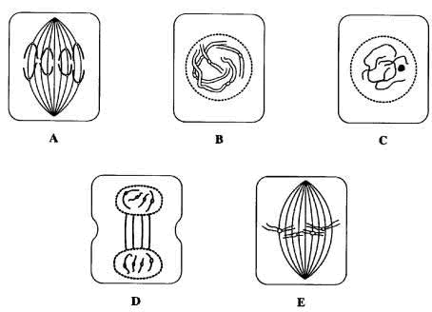

2. Draw cytokinesis

3. What type of reproduction occurs during this process? Asexual or sexual?

4. Which picture represents the resting phase

Meiosis
A. B. C.
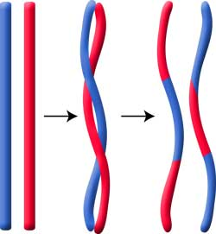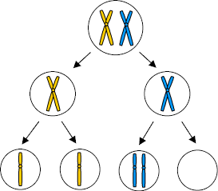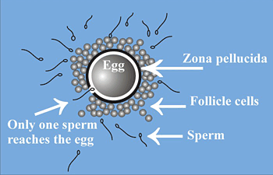

1. These three pictures represent processes that occur during sexual reproduction: Nondisjunction, fertilization, crossing over. Match the process with the correct picture.
a. ______________
b. ______________
c. ______________

2. All of these processes allow for _________________ in offspring.

Anaerobic Respiration
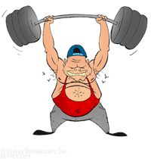

1. What is the name of the compound that builds up in muscle cells to make them sore after strenuous exercise?

2. Why can the body not be involved in anaerobic respiration very long?

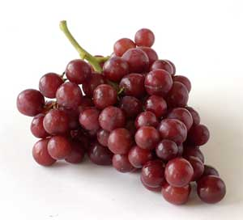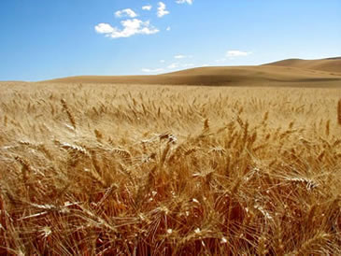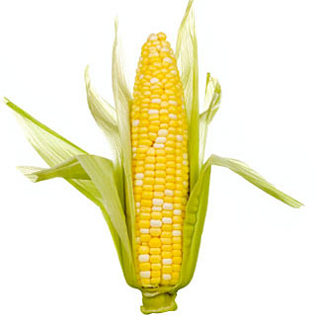

3. What is the name of the compound that is created by plants and yeast during anaerobic respiration?

4. What term is often used, when making this compound, instead of anaerobic respiration?

5. Which gas is not present during anaerobic respiration?

Aerobic Respiration

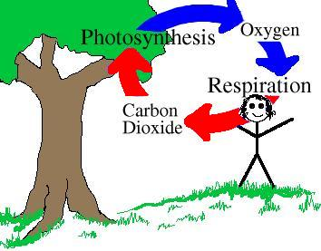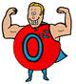

1. What gas is released during photosynthesis and used during aerobic respiration?

2. Why is aerobic respiration known as the “ideal” method of respiration?

3. Why must all living things be involved in cell respiration?

Photosynthesis

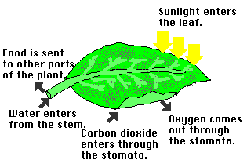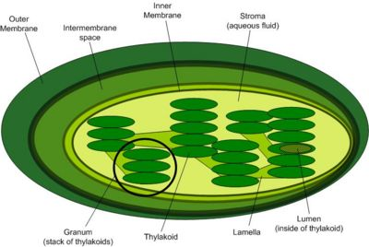

1. What is the end goal of photosynthesis for the plant?

2. What cell organelle is involved in photosynthesis?

3. What are the two beginning substances required for photosynthesis?

4. What are the two ending substances of photosynthesis?

Prokaryote vs. Eukaryote

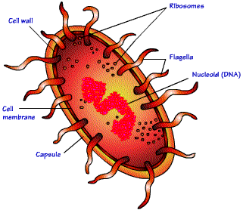

1. Which of these cells is a prokaryote cell? How do you know?

2. What structures do both of these cells have in common?

3. Compared to the eukaryote cell, the prokaryote cell is usually (smaller/larger).

4. What do we know about the chromosome number of all prokaryote cells? Where is this genetic material located?

Mitosis vs. Meiosis
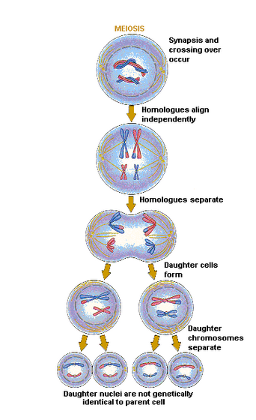
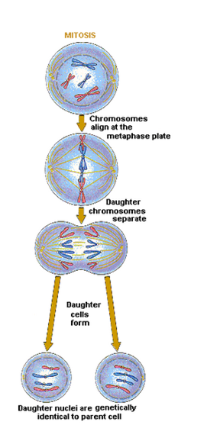

*Copy the table onto your paper.

 | Mitosis | Meiosis
# of cell divisions
# of ending cells
# of chromosomes in resulting cells (same/half)
sexual/asexual reproduction

Cell Differentiation/Specialization
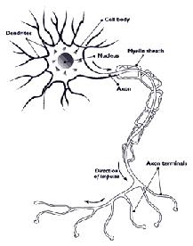
A. B. C.
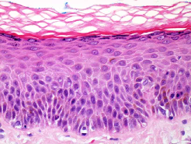
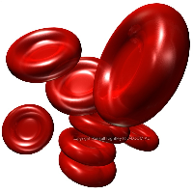

red blood cells skin cells nerve cell

1. How are these three cells able to be different even though they all come from the same organism?

2. Give the function of each cell
a. ________________________________
b. ________________________________
c. ________________________________

3. The bone marrow cavity of children and the bone ends of adults contain cells called hemocytoblasts that can reproduce and become any of the different types of blood cells. What do we call these cells that can become other types of cells?

Compound Matching

A. monosaccharides E. hemoglobin and insulin I. glycogen
B. nucleotides F. glucose J. phospholipids and steroids
C. amino acids G. DNA and RNA K. enzymes
D. fatty acids H. starch M. cellulose

1. small sugar created during photosynthesis
2. proteins that speed up reactions
3. small units of lipids
4. proteins found in the blood
5. large carbohydrate found in the cell walls of plants
6. small units of carbohydrates
7. large storage carbohydrate made by plants
8. examples of nucleic acids that contain an information code
9. small units of proteins
10. lipids create a flexible cell membrane
11. large storage carbohydrate made by mammals
12. small units of nucleic acids; made of a sugar, phosphate, and nitrogen base

