NAME ___________________________
Earth Science Wind/Pressure/Weather WebQuest
Part 1. Air Masses
1. http://en.wikipedia.org/wiki/Air_mass Find out what an air mass is.
a. What is an airmass? An airmass is a volume of air defined by its temperature and water vapor content.

b. Explain the difference between a “continental(c) ” air mass, and a “maritime(m)” air mass. Continental air mass is dry while maritime is moist.

c. Explain the difference between a “polar(P)” air mass and a “tropical(T)” air mass.
Polar air masses develop over higher latitudes over the land or ocean, are very stable, and generally shallower than arctic air. Tropical air mass develop over land. they are drier and hotter than those that develop over oceans.
2. They describe an air mass by its Moisture content and Temperature, so each air mass has two letters. Name each air mass and describe it by moisture content and temperature.
cP = Continental Polar air masses. This is air masses that are cold and dry due to their continental source region.
cT = Continental tropical air mass. Are warm and are found on land.
mP = Monsoon polar air mass. Are cold and are found in ice capes.
mT = Monsoon tropical air mass. Are found above the oceans.
Using the map on the webpage, label each of the bubbles below.

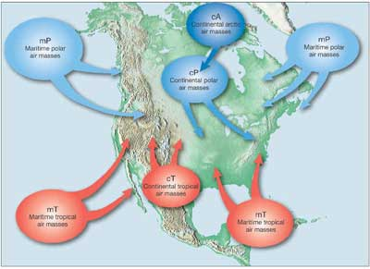

mP
mP

cP

cT

mT
mT

- Three air masses affect Pennsylvania’s weather the most. Name their air mass symbols and tell me where they come from. Cp, mP, and cA
2. Go to the website: http://www.weatherquestions.com/What_causes_high_pressure.htm to find out what causes a high pressure air mass.
a. What causes an air mass to have a high pressure? High pressure areas are usually caused by air masses being cooled, either from below or above.

3. The website http://www.weatherquestions.com/What_causes_low_pressure.htm will help you answer the following question:
a. What causes an air mass to have a low pressure? When atmospheric circulations of air up and down remove a small amount of atmosphere from a region.

4. Look at this picture: http://www.physicalgeography.net/fundamentals/images/thermal2.GIF. Does air move from high pressure to low, or low to high? From high to low.

Part 2. Global Winds
5. http://ww2010.atmos.uiuc.edu/(Gh)/wwhlpr/global_winds.rxml What are the Global Winds? They are the winds that go from the south pole to the north pole.
Label B – L in the diagram below.
B: polar easterlies, C: subpolar low, D: prevailing westerlies, E: subtropical high, F: tropical easterlies, G: intertropical convergence zone, H: tropical easterlies, I: subtropical high, J: prevailing westerlies, K: subpolar low, L: polar easterlies.
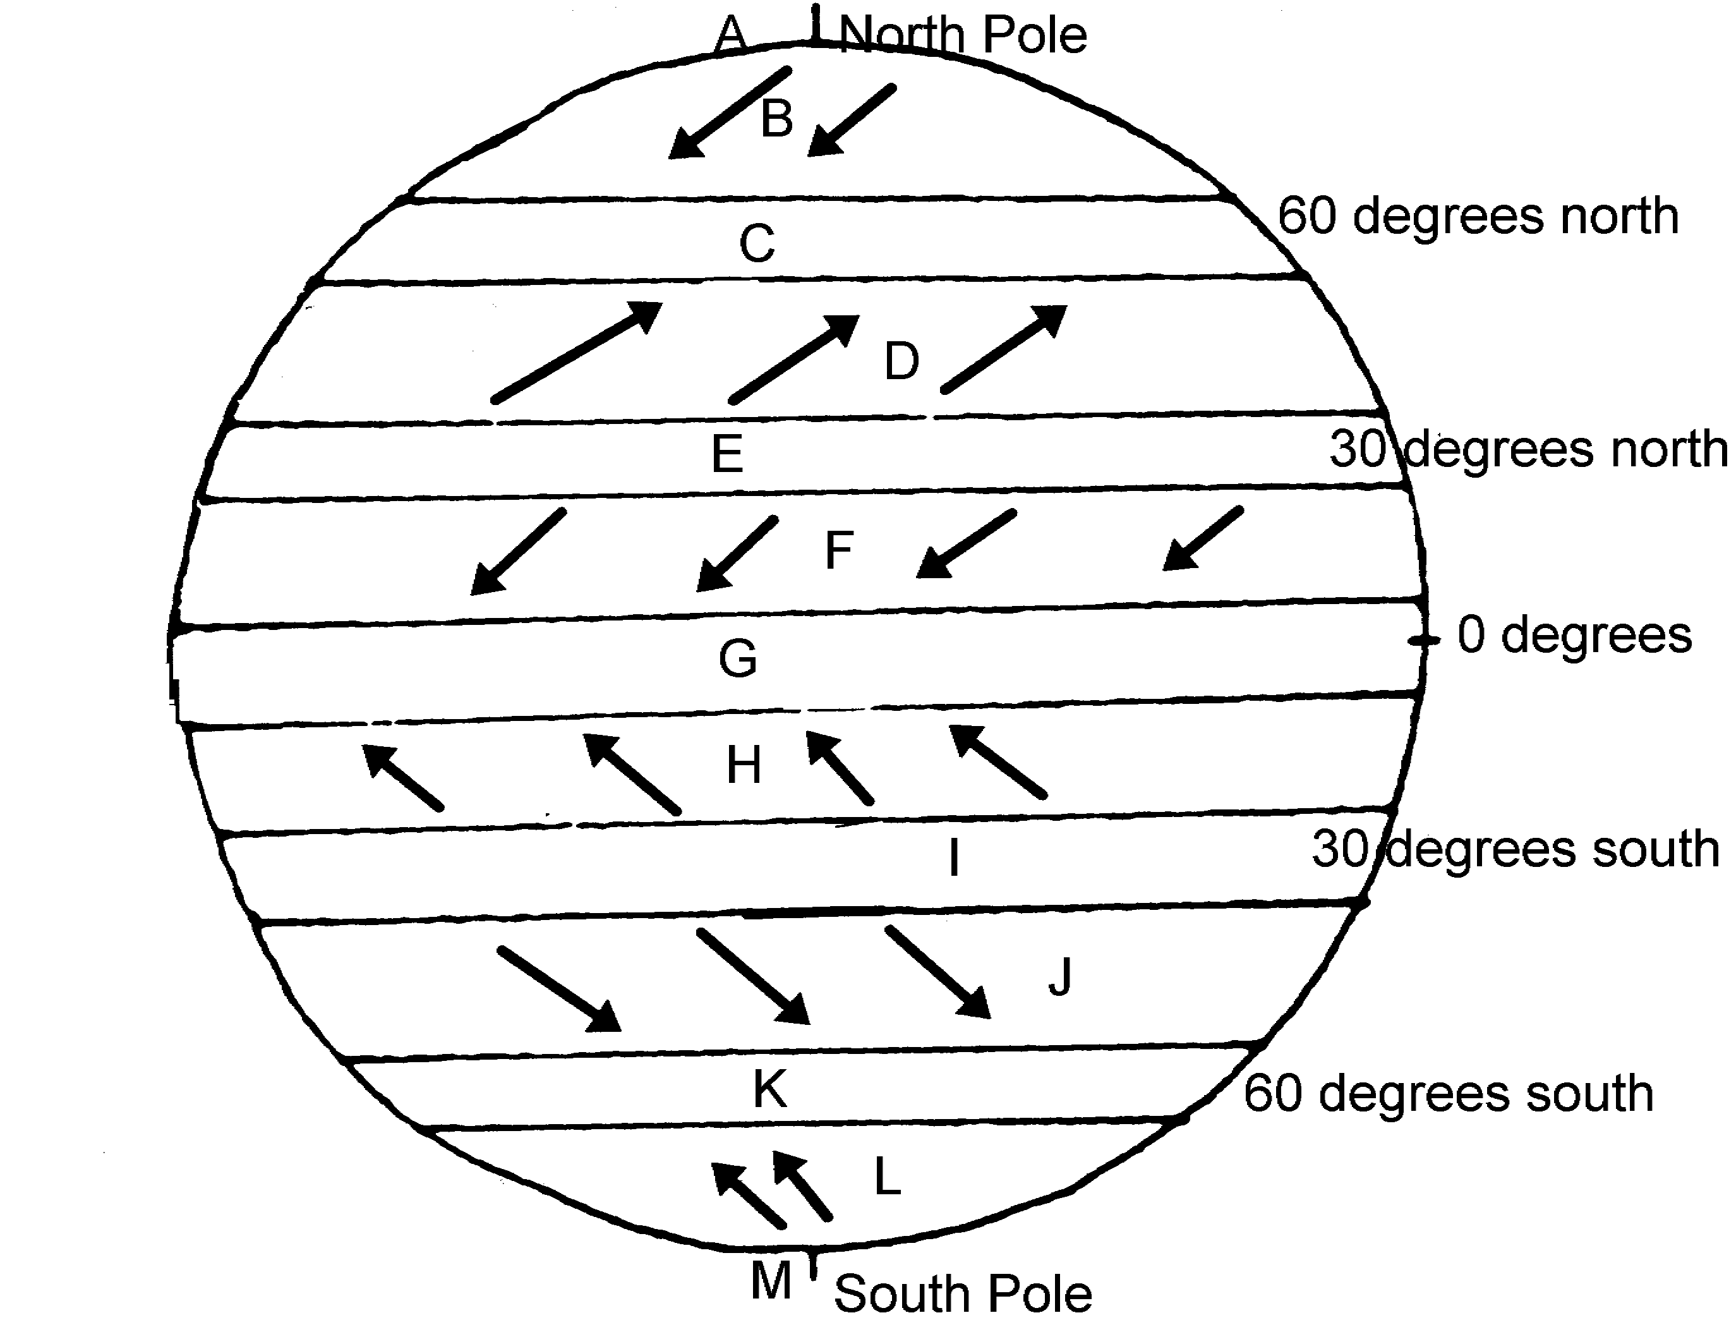
Part 3. Coriolis Effect
6. The Coriolis Effect affects Earth’s winds. Read the information at this website to find out about the Coriolis Effect: http://ww2010.atmos.uiuc.edu/(Gh)/guides/mtr/fw/crls.rxml . The video at the bottom will give you a visual of the Coriolis Effect.
a. Click on the “Pressure Gradient” link. What is the direction of the net force between two pressure systems? From high pressure to low pressure.
b. Click on the “High” link. What is a High Pressure Center and what does it mean? Where the pressure has been measured to be the highest relative to its surroundings. It means moving in any direction away from the High will result in a decrease in pressure.
c. In the video, why does the ball not roll straight across the merry-go-round? Because if its spinning on its axis it has a path it should follow like earth.

d. How is the Earth similar to the merry-go-round? (look at the figure) it spins on its axis like earth.

e. Wind is an object that is affected by the Coriolis Effect. What happens to winds in the Northern Hemisphere as a results of the Coriolis Effect? It’s directed to the right.

7. Use the animation at the following website to help you find out how the Coriolis Effect affects wind: http://www.classzone.com/books/earth_science/terc/content/visualizations/es1905/es1905page01.cfm .

a. Which way does the Coriolis Effect deflect wind in the Northern Hemisphere? To the right.

Part 4. Pressure Centers and Weather
8. Go to the website listed here: http://ww2010.atmos.uiuc.edu/(Gh)/wx/surface.rxml . Then, find the picture that says “Sea Level Pressure with IR satellite”. Click on this figure to bring up a new window. Click on the button that says “Aminate”. Choose “96 frames”. Answer the following questions:

a. This map shows you isobars and cloud cover. Click on the ? help to explain what an isobar is. It is a line drawn on a weather map connecting points of equal pressure.

b. Look at the map and find Chicago. Between which two isobars is Chicago? 124 and 128

c. Press “Play” on the window, and watch where the clouds travel. Do the clouds tend to be near High pressure centers (H) or Low pressure centers? The high pressure center.

9. This website will help explain why High pressure centers usually mean good weather, and Low pressure centers usually mean bad weather: http://www.usatoday.com/weather/tg/whighlow/whighlow.htm . Go here and read to discover why this is true, and then answer the following questions:

a. Air descends (comes down) at High pressure areas. Why does descending air not allow for clouds to form? As air rises it cools. As the air cools, the humidity in it begins to condense into tiny drops of water, or if it's cold enough, into tiny ice crystals. If there is enough water it will fall.

- Air ascends (goes up) at Low pressure areas. Why does ascending air allow for clouds to form?
As air descends, it warms, which inhibits the formation of clouds.
c. Use diagram to determine the direction of wind motion. What is the direction around a High pressure system? Clockwise spiral
d. What is the direction around a Low pressure system? Counterclockwise spiral

Part 5. Frontal Boundaries
10. This website will help you to understand a frontal boundary. Read the Introduction at the top and answer the following questions. http://www.phschool.com/atschool/phsciexp/active_art/weather_fronts/

a. What is a weather front? The area with two air masses with different tempters and densities collide, but do not mix
11. Play the Cold front animation and read the information above to answer the questions below.
a. Which air mass is doing the pushing? The cold air
b. What forms when the warm air gets pushed ”up” by the cold air? Warm air goes up and it creats a storm
c. What kind of clouds form at the frontal boundary? Cumulus and cumulonimbus
d. What weather is associated with this cloud type? Thunder storms and heavy rain
12. Play the Warm Front animation and answer the questions below.
a. Which air mass is doing the pushing? The warm air
b. What forms when the warm air rides “up” over the cold air? Clouds, storms, and rain
c. What kind of clouds form at this frontal boundary? Altostatus
d. What kind of clouds are at the very front edge of this boundary? Altocumulus
13. Below you will see on the weather map the symbol for a Cold Front is a Blue line with Triangles and a Warm Front is a Red line with half-circles. Label the diagram to show where the cool, dry (cP) air mass and the warm, moist (mT) air mass is in the picture.
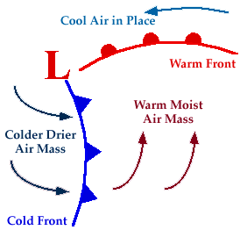
Cold front pushing warm front
Warm front going up
- Along which frontal boundary will thunderstorms develop? The warm front
- Along which frontal boundary will all-day rain occur? The cold front
- Look at the wind arrows on the diagram, do they match the direction of motion you determined in questions 9, d? What direction is that? Yes it is counter clock wise.

14. What happens at a Stationary Front? Sometimes when cold front and warm forts meet neither one has enough force to move each other.

15. Search the internet to find out the weather map symbol for a Stationary Front and draw below.
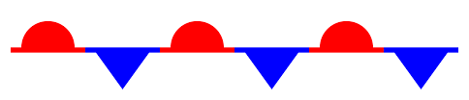

16. Click on this website to see the Current Weather Map. http://www.weather.com/maps/maptype/currentweatherusnational/index_large.html
a. Where is a Cold Front occurring? In the south east
b. Where is a Warm Front occurring? North West and south west
c. What type of air mass are we currently in? Cold air mass

